Nama : Zhoraya Andrea Ramadhani

NIM : 1207070131

Kelas : TKK

PRAKTIKUM PENGOLAHAN CITRA DIGITAL (8)

**MODUL 8 TRANSFORMASI CITRA**

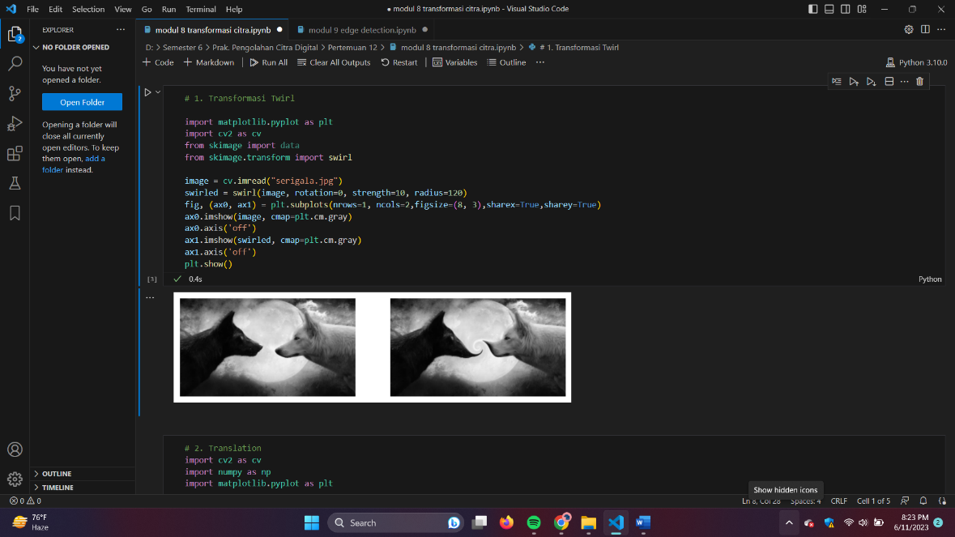

Gambar 8.1 Transformasi Twirl

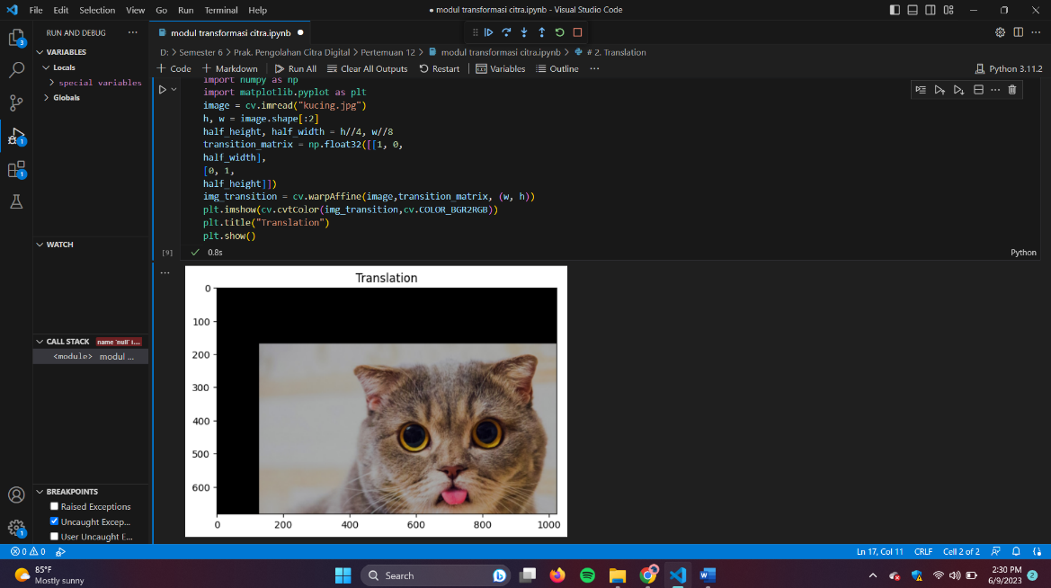

Gambar 8.2 Translation

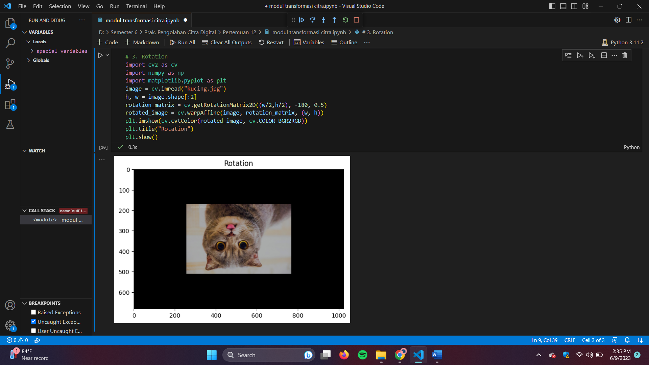

Gambar 8.3 Rotation

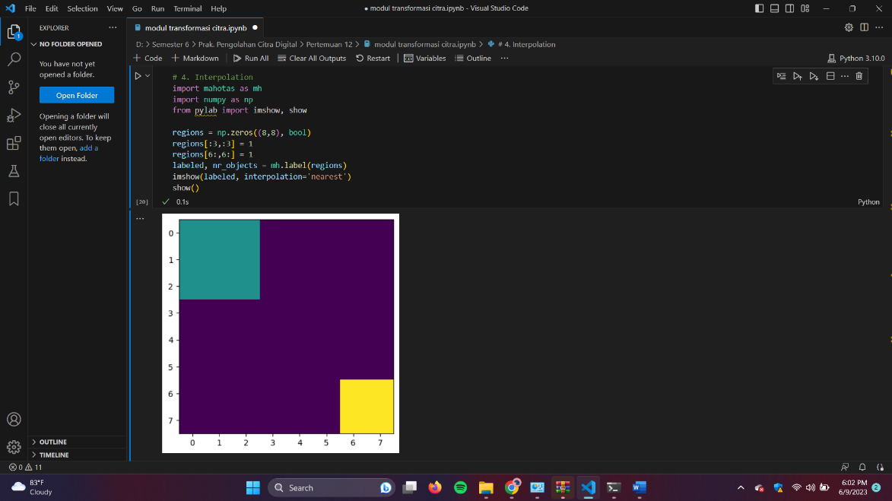

Gambar 8.4 Interpolation

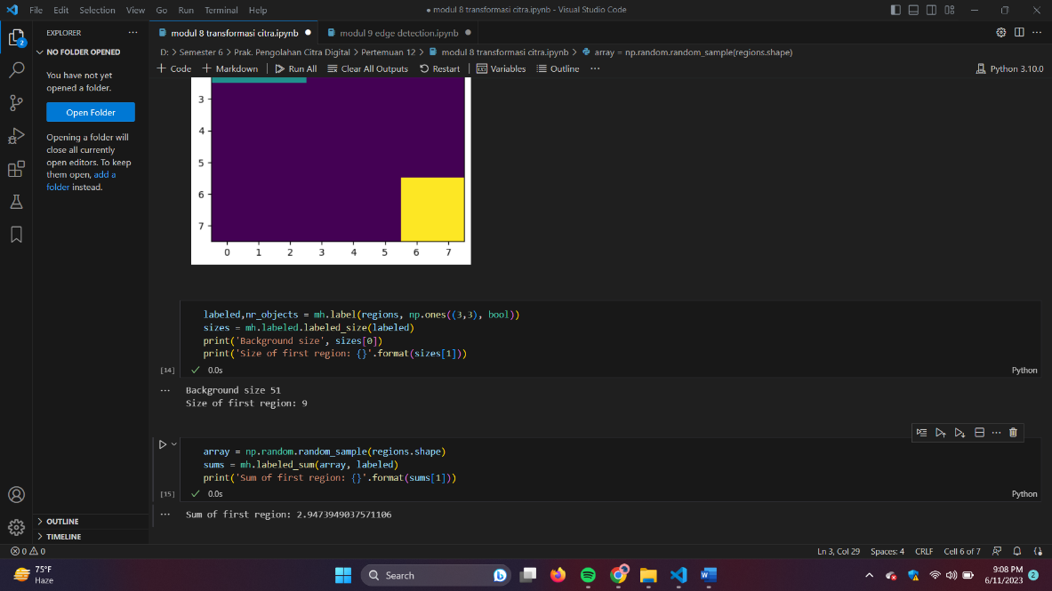

Gambar 8.4.1 Interpolation

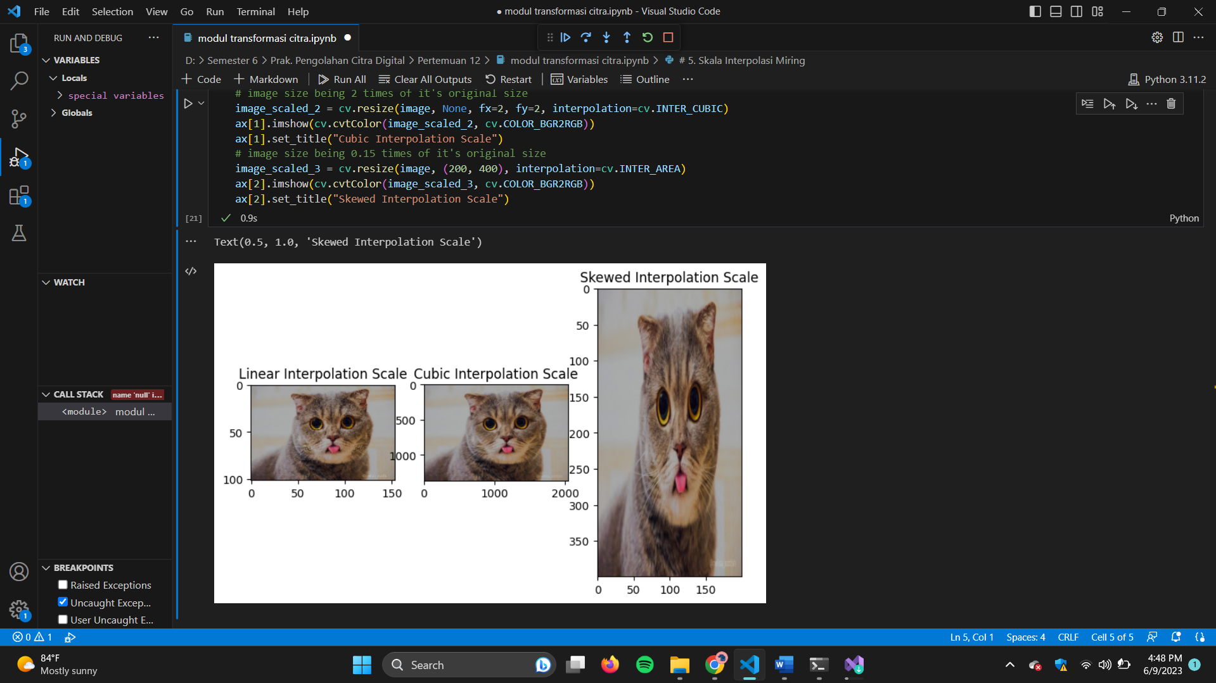

Gambar 8.5 Skala Interpolasi Miring

Link github: https://github.com/andreajoya23/1207070131_Zhoraya-Andrea-R_Prak.8.git